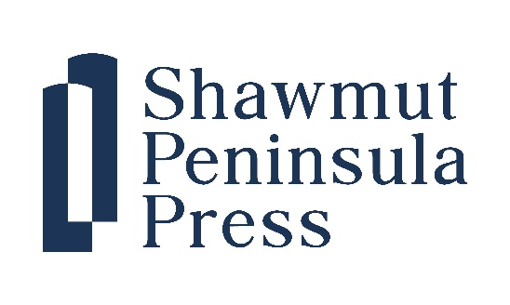

FOR IMMEDIATE RELEASE Contact: Russ López
Phone: (617) 331-8561
Email: Shawmut@s-ppress.com

Carmen Baca’s El Hermano named Finalist in New Mexico Book Awards 2025

October 14, 2025
Carmen Baca’s engrossing novel about life in early twentieth century New Mexico was named a Finalist in Historical Fiction in the 2025 New Mexico Book Awards. Administered by New Mexico Writers, the awards recognize excellence in literature produced in The Land of Enchantment.

About El Hermano:
El Hermano is set in rural New Mexico. Between the World Wars in remote mountain hamlets and villages, the people’s religious well-being is looked after by a Cofradía, a brotherhood, also known as Penitentes for their austere rituals, some of which were done in secret. El Hermano takes place during the forty days of Lent in 1928 as José and his cousins conspire to spy on one of the brotherhood’s secret rituals to see what lies ahead for them as novices. José knows his time to join the cofradías (of which his own father is Hermano Mayor) is near, but having seen Hermanos who appear to be in pain after a night spent at the morada, a meeting house and chapel, and having heard stories about those who even died in the past because of whatever went on within the sacred structure, his fear guides him to join his cousins in their clandestine scheme. Little do they know, certain New Mexican legends conspire against them; La Muerte, Saint Death, warns José to leave his future unknown, a ball of fire thought to be a witch crosses their path, and even la Llorona, ghost of the Weeping Woman, and el Diablo, the Devil make an appearance.

About Carmen Baca:

A Chicana Norteña native to New Mexico, Carmen Baca is the author of seven books and multiple short publications from prose to poetry in a variety of genres, including folk horror, speculative fiction, and nonfiction. She is a recipient of New Mexico Magazine's 2023 True Hero award for celebrating and preserving her culture through story telling. Two of her short works were nominated to Best of the Net and the Pushcart Prize also in 2023.

About New Mexico Writers:
New Mexico Writers is a nonprofit organization dedicated to supporting and connecting the state’s literary community. In today’s world, literary voices are more important than ever. New Mexico Writers is committed to supporting the diverse and original writers who populate the state and to continuing its long tradition of literary excellence and creative community.

About Shawmut Peninsula Press:
Based in Boston, Massachusetts, Shawmut Peninsula Press specializes in books that focus on perspectives from outside the mainstream. We aim to showcase writing that provokes thought as well as entertains.

